**A Map of the Inorganic Ternary Metal Nitrides**

Wenhao Sun1, Christopher Bartel2, Elisabetta Arca3, Sage Bauer3, Bethany Matthews4, Bernardo Orvañanos2, Janet Tate4, William Tumas3, Andriy Zakutayev3, Stephan Lany3, Aaron Holder3, Gerbrand Ceder1,5

1 Materials Sciences Division, Lawrence Berkeley National Laboratory, Berkeley, California 94720, USA

2 Department of Chemical and Biological Engineering, University of Colorado, Boulder, Colorado 80309, USA

3 National Renewable Energy Laboratory, Golden, Colorado 80401, USA

4 Department of Physics, Oregon State University, Corvallis, Oregon 97331, USA.

5 Department of Materials Science and Engineering, UC Berkeley, Berkeley, California 94720, USA

**Using the interactive map of the ternary metal nitrides**

To view the interactive ternary nitrides map, extract the attached **InteractiveTernaryNitridesMap.zip** file into a folder, and open **TernaryNitridesMap.html**. Hovering the mouse cursor over an individual M1-M2-N entry on the ternary nitrides map will show the corresponding ternary nitride phase diagram, along with a table of stable and metastable entries. An example is shown below for the Zn-Ti-N system.

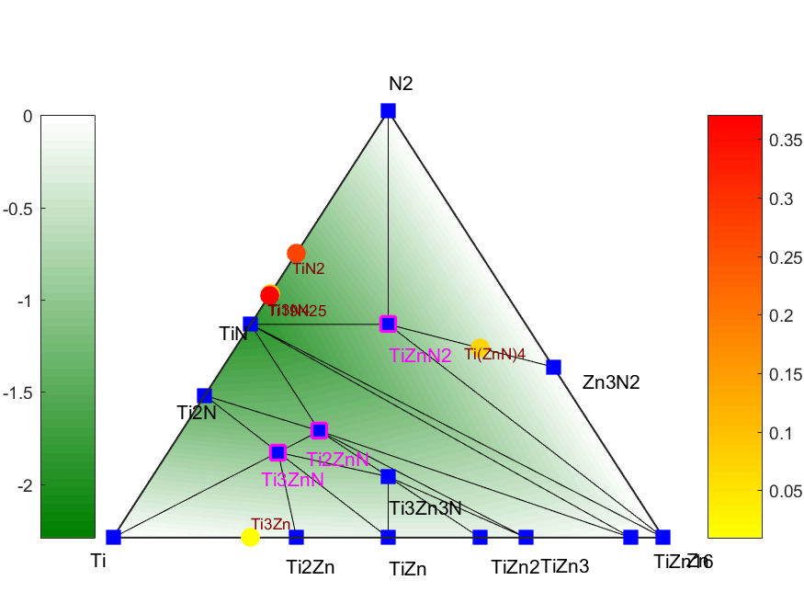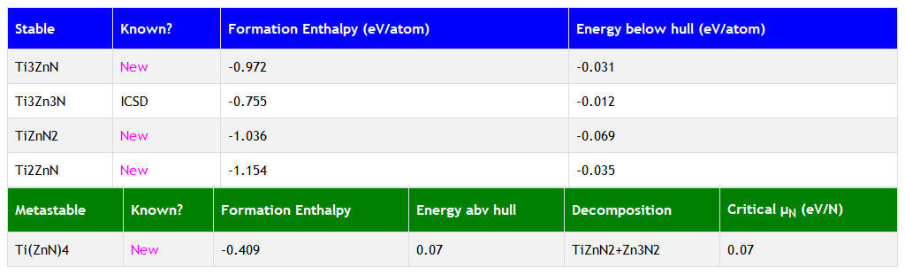

The green background of the ternary phase diagram corresponds to the depth of the ternary convex hull as a function of composition; color coded by the formation energy as shown on the left colorbar (units of eV/atom). Stable phases are indicated on the ternary phase diagram by a blue square. New stable ternaries predicted in this work are indicated by a magenta box (in this example, Ti3ZnN, Ti2ZnN, TiZnN2). Stable ternaries without a magenta box (such as Ti3Zn3N) can be found in the ICSD. The ‘energy below hull’ indicates the reaction energy of a stable ternary nitride from its stable neighbors in phase space.

Metastable compounds are indicated by a circle, with the energy above the hull indicated by the color bar on the right, in units of eV/atom. To avoid clutter, we only include metastable compounds with an energy above the hull < 400 meV/atom. Note that we previously found the 90th percentile of nitride metastability to be 200 meV/atom.[1] If there are no ternary nitrides within 400 meV/atom of the hull, then the lowest formation energy metastable ternary is listed on the table below. The table also includes the decomposition products of a metastable ternary nitride. For metastable ternary nitrides that decompose to N2, we also provide a critical μN that can stabilize these metastable compounds, see Ref [2] for thermodynamic details.

The most up-to-date crystal structures for these compounds, along with their computed properties, can be obtained by searching for these compositions on the Materials Project.

The interactive map was programmed in Bokeh, an interactive python visualization library.[3] Buttons on the bottom of the map can be used to turn on/off the ICSD triangles, the hover-feature for phase diagram information, and the crosshair feature. Zooming in or out of the map using your internet browser   
(Ctrl + ‘=/–’) may facilitate your viewing of the map.

We find that the map seems to work best when using the Google Chrome browser.

Running the interactive features of the map via the Bokeh interface may require an internet connection.

References

1. Sun, Wenhao, et al. "The thermodynamic scale of inorganic crystalline metastability." *Science Advances* 2.11 (2016): e1600225.
2. Sun, Wenhao, et al. "Thermodynamic Routes to Novel Metastable Nitrogen-Rich Nitrides." *Chemistry of Materials*29.16 (2017): 6936-6946.
3. Bokeh Development Team (2018). Bokeh: Python library for interactive visualization, URL http://www.bokeh.pydata.org.